Section IV: Contract Forms
eSourcing reference: RFQ/2026/62289

IV-1: UNOPS General Conditions of Contract

In the event of a Contract, the following General Conditions of Contract will apply:

- UNOPS General Conditions of Contract for the provision of Goods and Services

The conditions are available at: https://www.unops.org/business-opportunities/how-we-procure

IV-3: UNOPS sample contract for [Purchase Order]

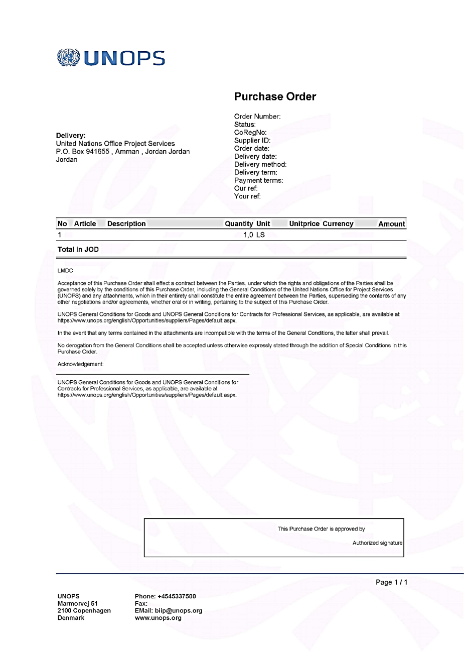

Performance Security Form (Bank Guarantee)
Note to bidders: This form, when required, shall only be completed by the successful Bidder after contract award. The bank, as requested by the successful bidder, shall fill in this form in accordance with the instructions indicated.

Date: [Insert date (as day, month, and year) of submission]
ITB No. and title: [xx-xxx and title of the ITB]

Bank’s Branch or Office: [Insert complete name of guarantor]
Beneficiary: [Insert legal name and address of UNOPS]
Performance Guarantee No.: [Insert Performance Guarantee number]
We have been informed that [insert complete name of supplier] (hereinafter called "the supplier") has entered into Contract No. [Insert number] dated [Insert day and month], [Insert year] with you, for the supply of [description of goods and related services] (hereinafter called "the contract"). Furthermore, we understand that, according to the conditions of the contract, a Performance Guarantee is required.
At the request of the supplier, we hereby irrevocably undertake to pay you any sum(s) not exceeding [insert amount(s) in figures and words], upon receipt by us of your first demand in writing declaring the supplier to be in default under the contract, without cavil or argument, or your needing to prove or to show grounds or reasons for your demand or the sum specified therein.
This guarantee shall expire no later than the [insert number] day of [insert month] [insert year], and any demand for payment under it must be received by us at this office on or before that date.
This guarantee is subject to the Uniform Rules for Demand Guarantees (2010 Revision), International Chamber of Commerce Publication No. 758, except that the supporting statement under article 15(a) is excluded.
______________________________
[Signatures of authorized representatives of the bank and the supplier]

The bank shall insert the amount(s) specified in the SCG and denominated, as specified in the SCG, either in the currency(ies) of the Contract or a freely convertible currency acceptable to UNOPS.
Dates established in accordance with Clause 12 of the General Conditions of Contract (“GCG”). UNOPS should note that in the event of an extension of the time to perform the Contract, UNOPS would need to request an extension of this Guarantee from the Bank. Such request must be in writing, and must be made prior to the expiration date established in the Guarantee. In preparing this Guarantee, UNOPS might consider adding the following text to the Form, at the end of the penultimate paragraph: “We agree to a one-time extension of this Guarantee for a period not to exceed [six months] [one year], in response to UNOPS’s written request for such extension. Such a request is to be presented to us before the expiry of the Guarantee.”

